**SC2006 Software Engineering**



**Lab#1 Deliverables**

Lab Group SSP1

Group Name: Depressed Elderly

Lab Supervisor: Liu Yang

| Group Members | |
| --- | --- |
| Name | Matriculation No. |
| Johnny | U2121697B |
| Bertranne Lee Zi - Wen | U2120209L |
| Yap Shen Hwei | U2140630E |
| Koh Jia Wei | U2121270D |
| Zhi Guang | U2120504C |
| Chong Yue Hong | U2120181D |

Table of Contents

**1.0 Documentation of Functional and Non-functional requirements** **3**

1.1 Functional Requirements 3

Account 3

1.2 Non-functional requirements 6

**2.0 Data Dictionary** **7**

**3.0 Initial Use Case Model** **8**

**4.0 UI Mockups** **9**

4.1 Login Page 9

4.1.1 Login Page (Error) 10

4.1.2 Login Page (Forgotten Password) 11

4.2 Registration Page 12

4.3 Landing Page 13

4.3.1 Landing Page (Selecting Job) 14

4.3.2 Landing Page (Accepting Job) 15

4.3.3 Landing Page (Job Details - Servicer) 16

4.3.4 Landing Page (Messaging - Chat Logs) 17

4.3.5 Landing Page (Messaging - User to User) 18

4.3.6 Landing Page (Job - Details - Requester) 19

4.4 Account Page 20

4.4.1 Account Page (Edit Details) 21

# 1.0 Documentation of Functional and Non-functional requirements

## 

## 1.1 Functional Requirements

### Account

* 1. Users must be able to register for a new account.
     1. System must create a new account for the user once all requirements are fulfilled.
        1. System must prompt the user to change the username if it is taken.
        2. System must prompt the user to change the passwords if the password didn’t adhere to requirements: at least 1 special character, letters in mixed cases, at least 8 characters.
        3. System must prompt the user to change the phone number if there is a phone number linked to an existing account.
        4. System must prompt the user to change the email address if there is an email address linked to an existing account.
     2. System must send a confirmation email to the user when a new account is successfully created.
  2. Users must be able to login to the account with username and password.
     1. After the user submits details, the system must validate the user’s username and password.
     2. System shall show the main landing page.
     3. Users must be able to view their profile after clicking the profile tab.
     4. Users must be able to modify their profile if they want
        1. Any changes made by users must fulfilled the requirements according to 1.1.1
        2. System must able to update the profile picture after edit the profile picture
        3. System must able to update the email after email has been changed by user.
        4. System must able to update the bio after bio has been changed by user.
        5. System must able to update the phone number after phone number has been changed by user.
  3. Users must be able to reset the password if they had forgotten their passwords.
     1. System must send an email to users to reset the password.
     2. System must prompt the user to change the password if the new password didn’t adhere to requirements: at least 1 special character, letters in mixed cases, at least 8 characters.
     3. System must prompt the user to change the password if the new password is used before.

1. Job
   1. Requesters must be able to create job requests.
      1. System must ensure the job request has a job name.
      2. System must ensure the job request has a job description.
      3. System must ensure the job request has a location specified.
      4. System must ensure the job request has date and time specified.
      5. System must ensure the job request has a salary specified.
      6. System must ensure the requester specifies the payment method.
      7. System must add the job request to the existing job listing after the job request is successfully created.
   2. Requesters must be able to edit job requests if the job request hasn’t been accepted.
      1. System must update the changes to the job.
   3. Requesters must be able to delete job requests
      1. System must remove the job request from the job listing.
      2. System must penalise requesters after the servicers have accepted for 3 minutes
   4. Servicers must be able to filter through the available jobs.
      1. System shall allow servicers to filter by keywords, salary and location.
   5. Servicers must be able to accept job requests.
      1. System must create a job contract with all details on it.
      2. System must add the job to the servicer’s “Job List”.
         1. System must set the job status to active.
      3. System must remove the job request from the job listing.
      4. System must ensure both servicers and requesters are able to contact each other after the job contract is created.
      5. System must allow both servicers and requesters to contact through the app.
   6. Servicers must be able to retract services
      1. System must add the job request to the job listing.
      2. System must penalise servicers after the servicers have accepted the job for 3 minutes.
   7. Requesters must be able to report if any emergency situation occurred.
      1. System must immediately alert customer service.
   8. Requesters must be able to end the job after it is completed.
      1. Servicers must be able to check the “I have received payment”.
      2. System must change the job status to history.
      3. Requesters must be able to rate and review the servicers.
         1. System must update any comments and ratings in the servicer’s profile.
      4. Servicers must be able to rate and review the requesters.
         1. System must update any comments and ratings in the requester’s profile.

## 1.2 Non-functional requirements

1. Performance
   1. The application shall take within 3 seconds to load in
   2. The sign up and sign in page shall take within 1 second to load.
   3. The validation email for sign up shall take within 1 min to arrive.
   4. Reseting password shall take 1 second to update in the system.
   5. Each function module shall take within 1 seconds to load in.
   6. System must add the new job request to the job listing in 1 minute.
   7. Details of job shall take within 2 seconds to load.
   8. The application shall take within 3 seconds to exit.
   9. All reminding messages shall take within 0.5 second to load in.
   10. Accepting and posting jobs shall take within 1 second to be updated in the system.
   11. Map must be displayed within 1 second.
   12. Information of jobs must be displayed within 1 second.
2. Safety Requirements
   1. Users shall add friends via this application and chat.
   2. Team shall maintain the system
   3. Team shall testing and debugging theapplication beforehand.
3. Security Requirements
   1. If the user enters in the wrong password more than 3 times , the account will be locked
   2. Users have to log in their account in order to post or accept jobs.
   3. The system shall handle exceptions.
      1. Reminding message shall display when the user enters two different passwords when setting or resetting the password.
      2. Reminding message shall display when the user inputs the wrong verification code.
   4. The application must not leak user information.
      1. User information must not be seen or used by others.
      2. User information must be deleted if the user account is deleted.

# 2.0 Data Dictionary

| Term | Definition |
| --- | --- |
| User | A person who has a registered account and is using the services provided by the application. |
| Account | The profile of the user in our system which contains details (Name, Username, Email, Phone Number, Rating) associated with them. |
| Username | A unique name that is associated with the user. |
| Password | A string of characters (letters, numbers, special symbols) that allow the user to access their account |
| Job | An instance of an ad hoc request created by a requester which details such as location, time, description, number of people needed and salary.  Jobs are completed by the servicer. |
| Contract | An agreement which is created when a requester has accepted the help from a Servicer(s). |
| Requester | A user who creates a job request in the system |
| Servicer | A user who does the job created by a requester |
| Rating | A numerical way to indicate how well a Servicer or Requester worked when the job has been completed. They will be rated on a 1 - 5 system (1 = worst, 5 = best) |
| Review | A short description which allows both users to talk about their experience doing the job. |

## 

# 3.0 Initial Use Case Model

3.1 Use Case Diagram

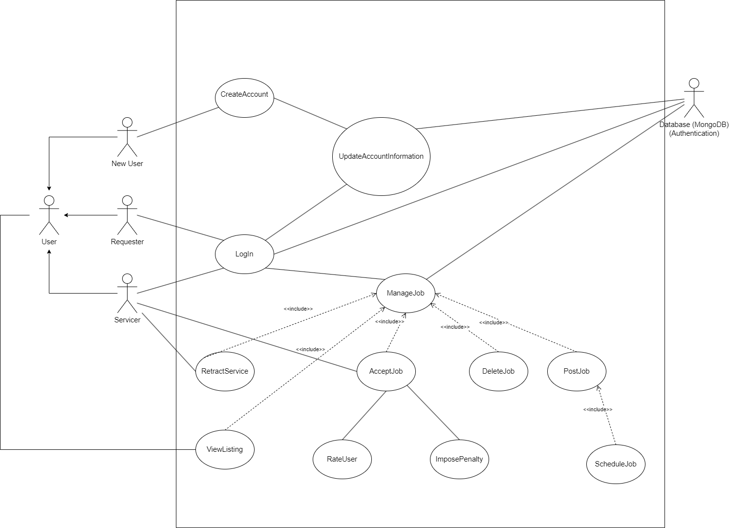

3.2 Use Case Description

# 4.0 UI Mockups

## 4.1 Login Page

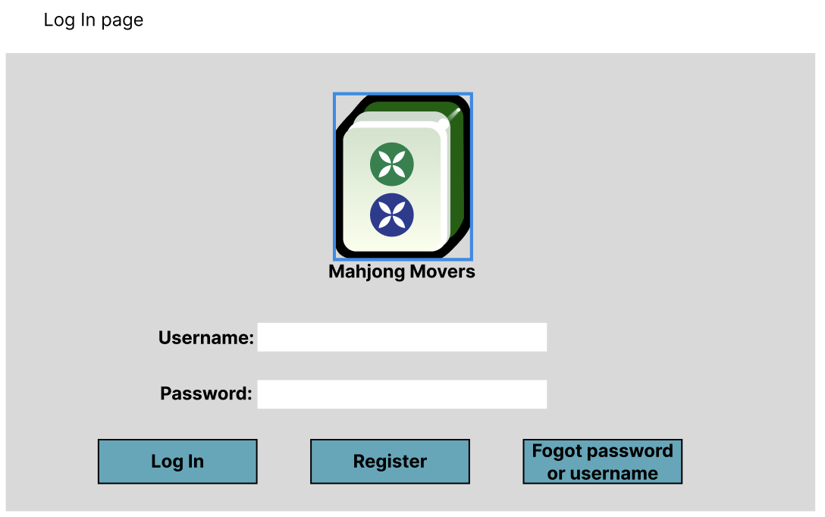

## 4.1.1 Login Page (Error)

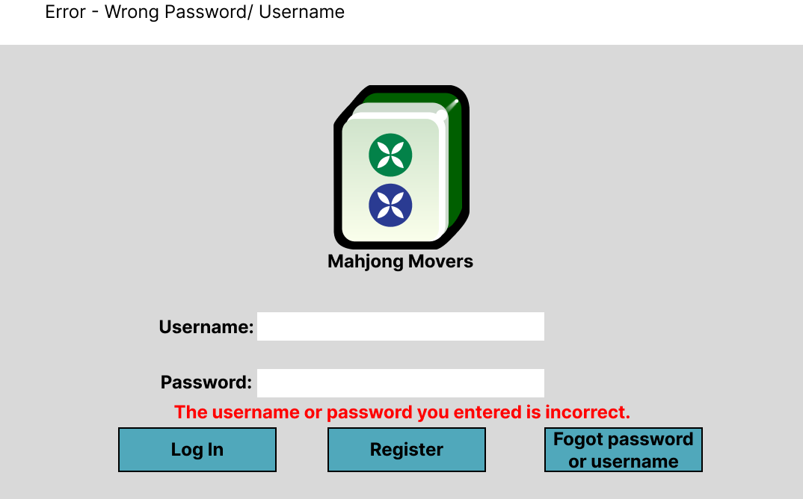

## 4.1.2 Login Page (Forgotten Password)

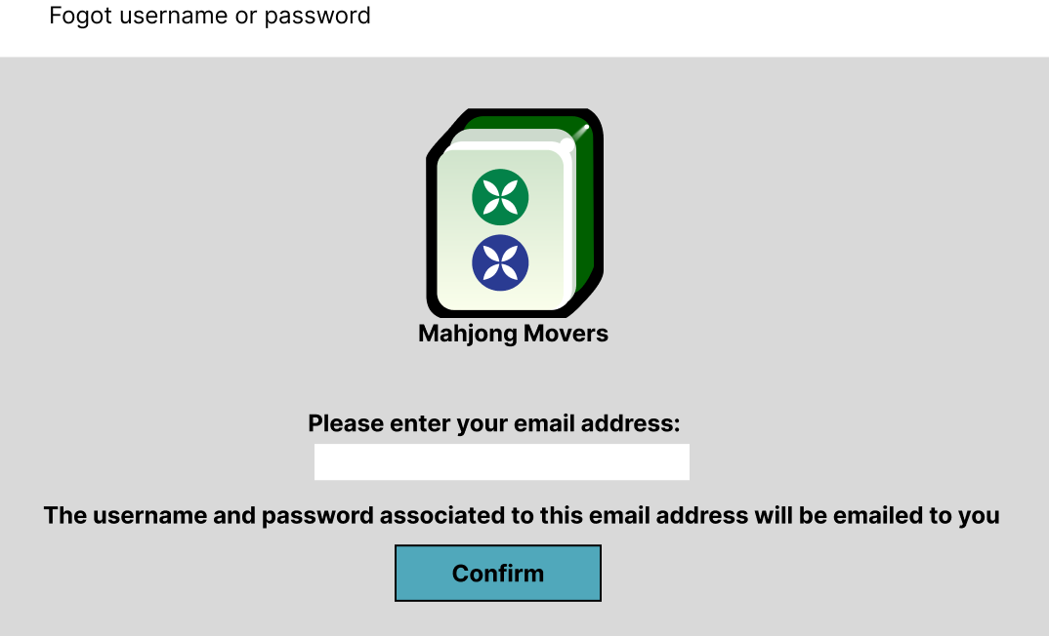

## 4.2 Registration Page

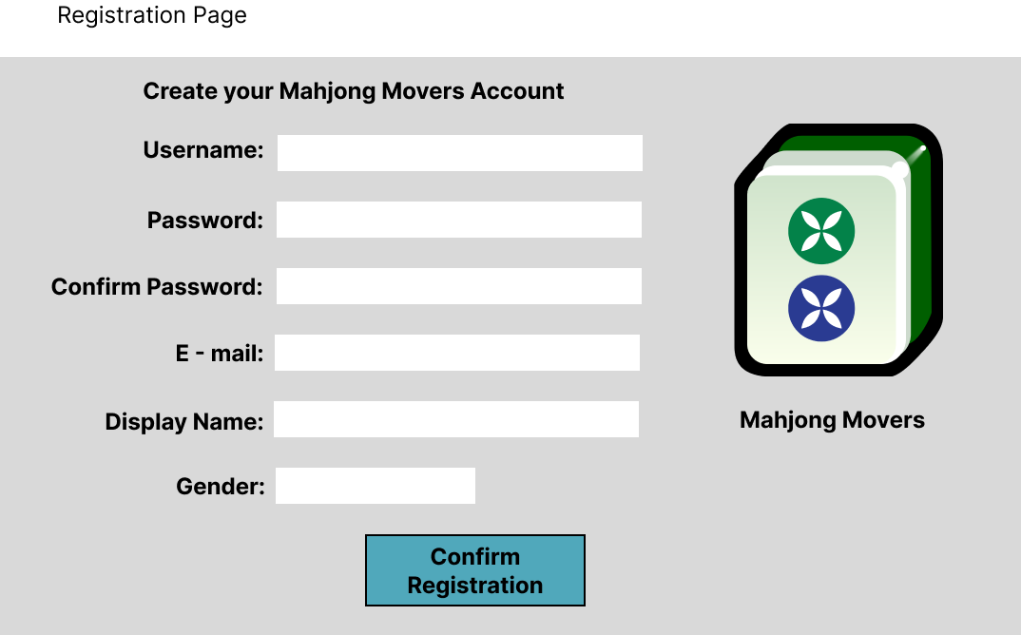

## 4.3 Landing Page

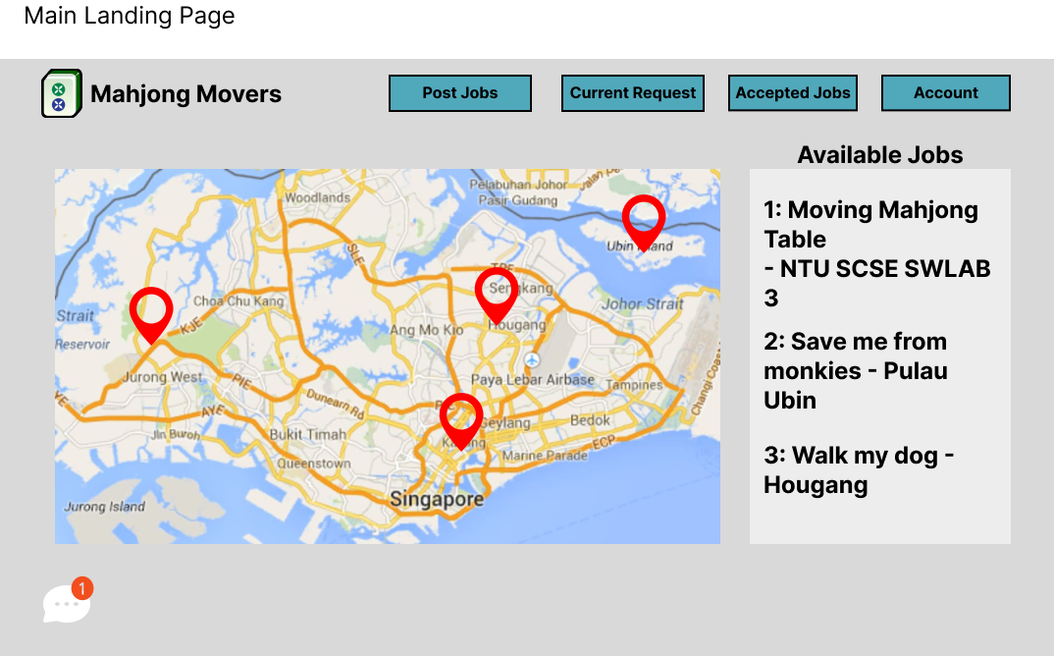

## 4.3.1 Landing Page (Selecting Job)

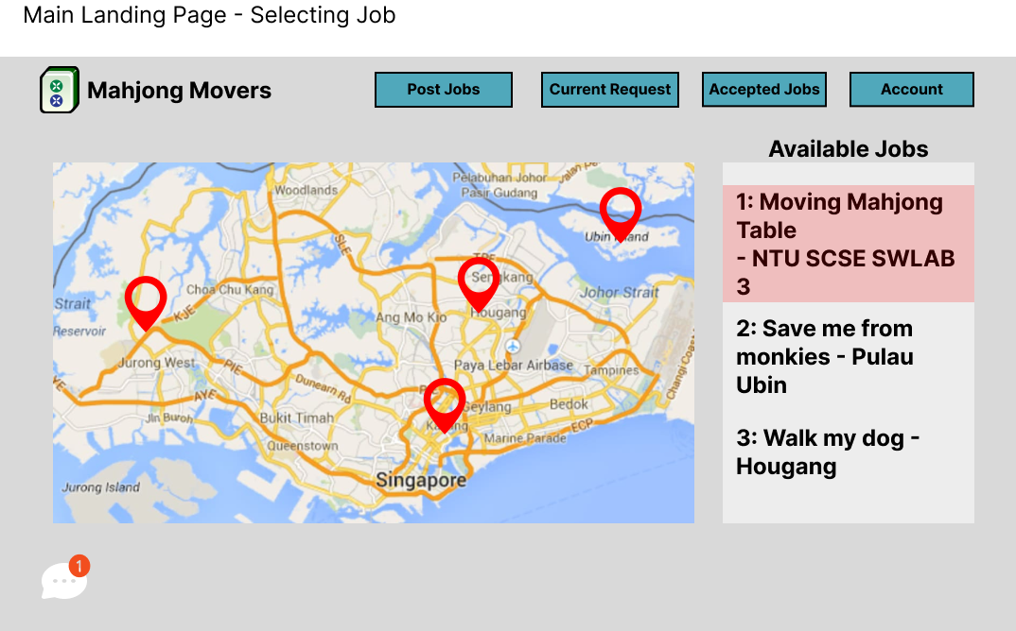

## 4.3.2 Landing Page (Accepting Job)

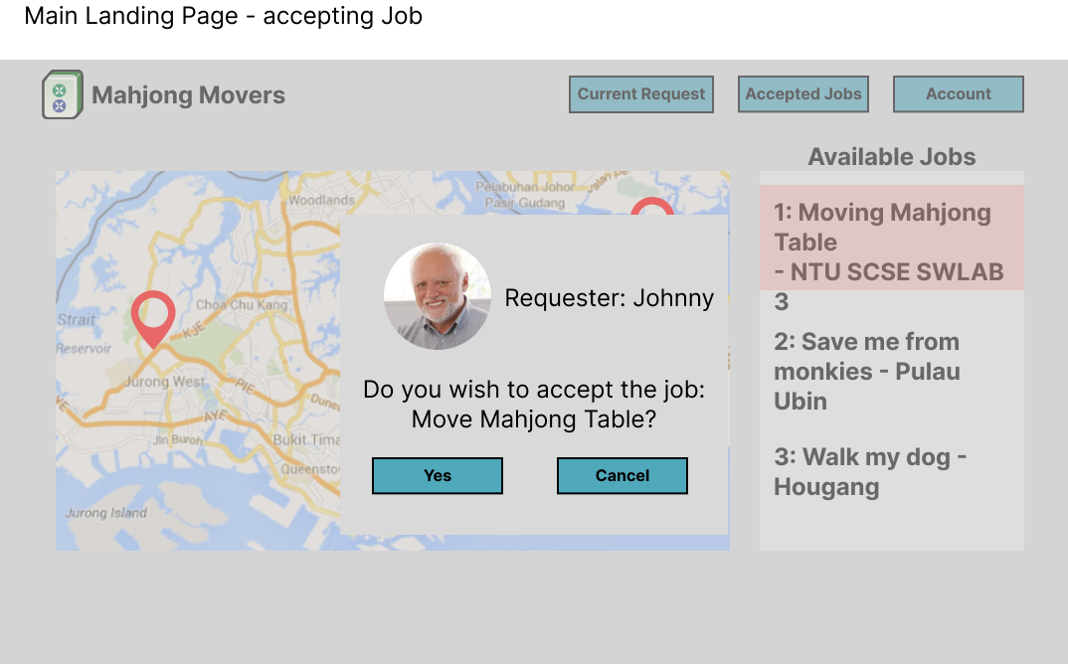

## 4.3.3 Landing Page (Job Details - Servicer)

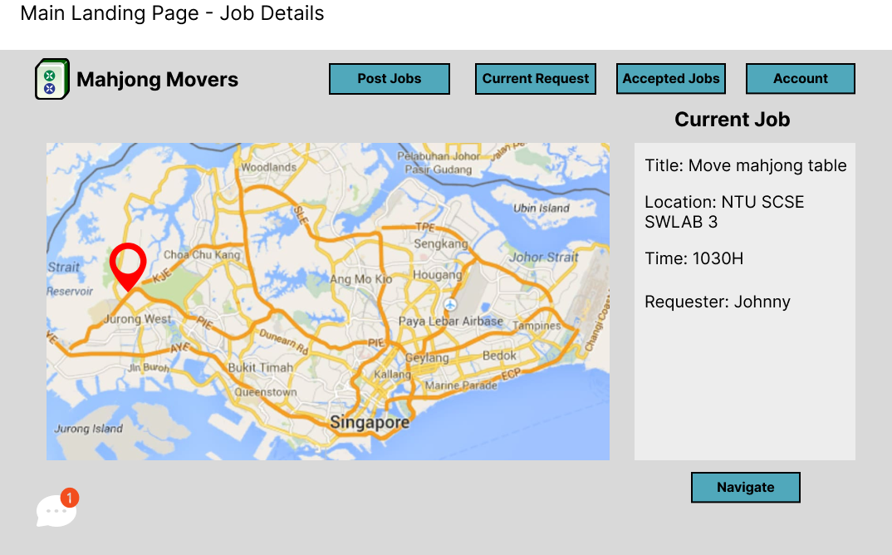

## 4.3.4 Landing Page (Messaging - Chat Logs)

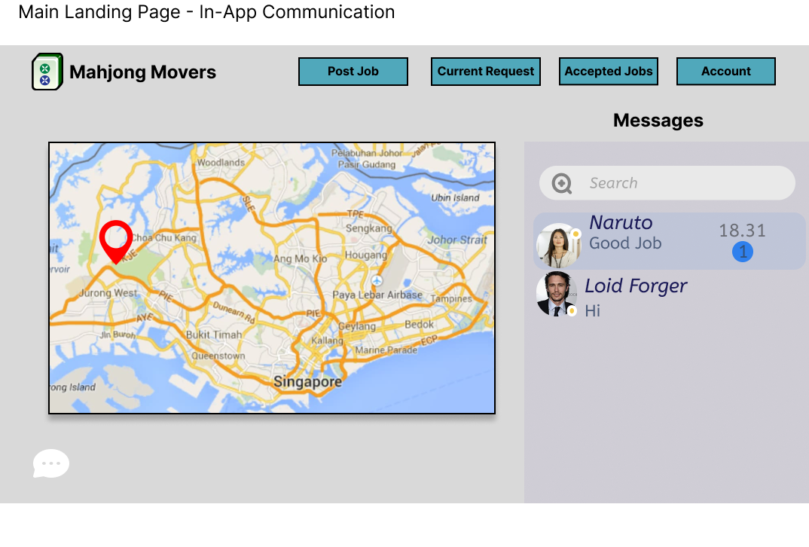

## 4.3.5 Landing Page (Messaging - User to User)

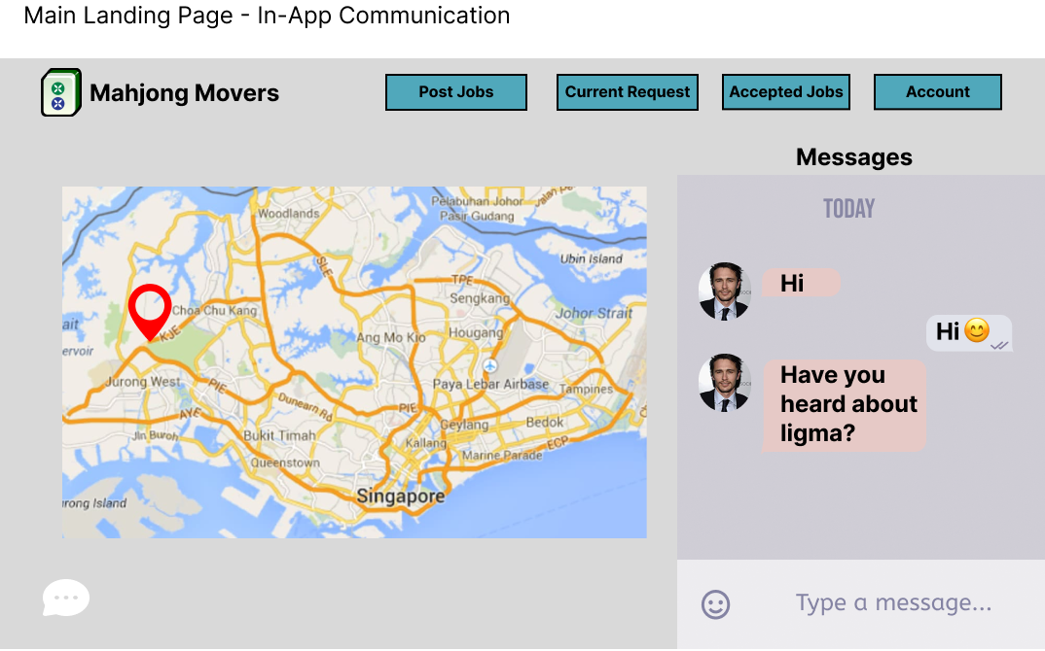

## 4.3.6 Landing Page (Job - Details - Requester)

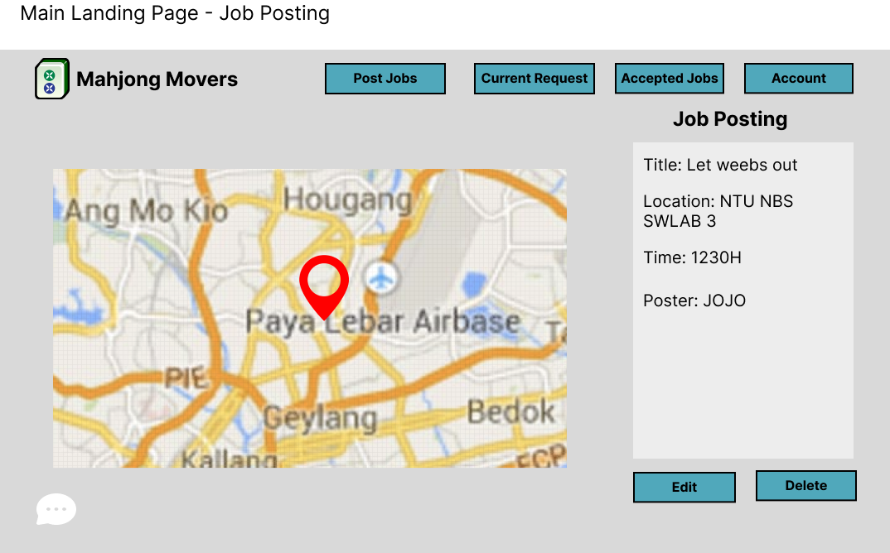

## 4.4 Account Page

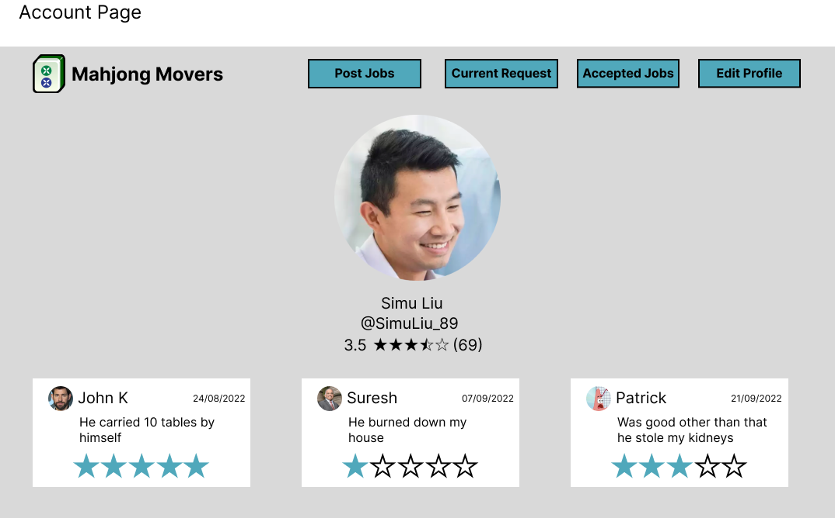

## 4.4.1 Account Page (Edit Details)

